Pierpont Bay Yacht Club
Santa Cruz Island 2023

Dates; FRI-. SUN. Aug 4-6 2023
Destination : Pelican Bay or Fry’s

Contact: Andy Fried (818) 427-0871 andyfried@earthlink.net
Monitor channel 16; Working channel 68
EVENTS: Sail or power out Fri. AM. Anchor, explore, fish, kayak, maybe hike. Potluck Sat night. Sail back on Sunday. Landing permit required for each boat if anyone wants to go ashore. To apply for landing permit go (https:www.nature.org/cruzpermit.)

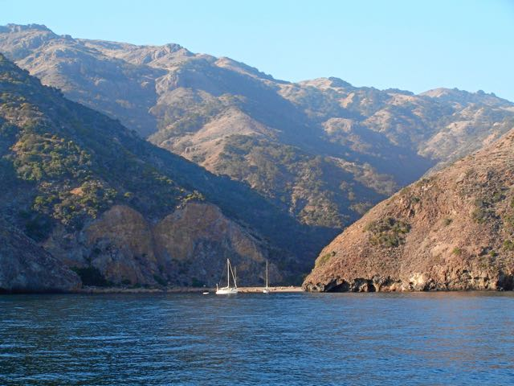
Fry’s harbor.

